CS 255 System Design Document Template

This template lays out all the different sections that you need to complete for Project Two. Each section has guidance to prompt your thinking. You will need to continually reference the interview transcript as you work to make sure that you are addressing your client’s needs. There is no required length for the final document. Instead the goal is to complete each section based on what your client’s needs are. Remove this note when you are finished, and replace all bracketed text with the relevant information.

UML Diagrams

UML Use Case Diagram
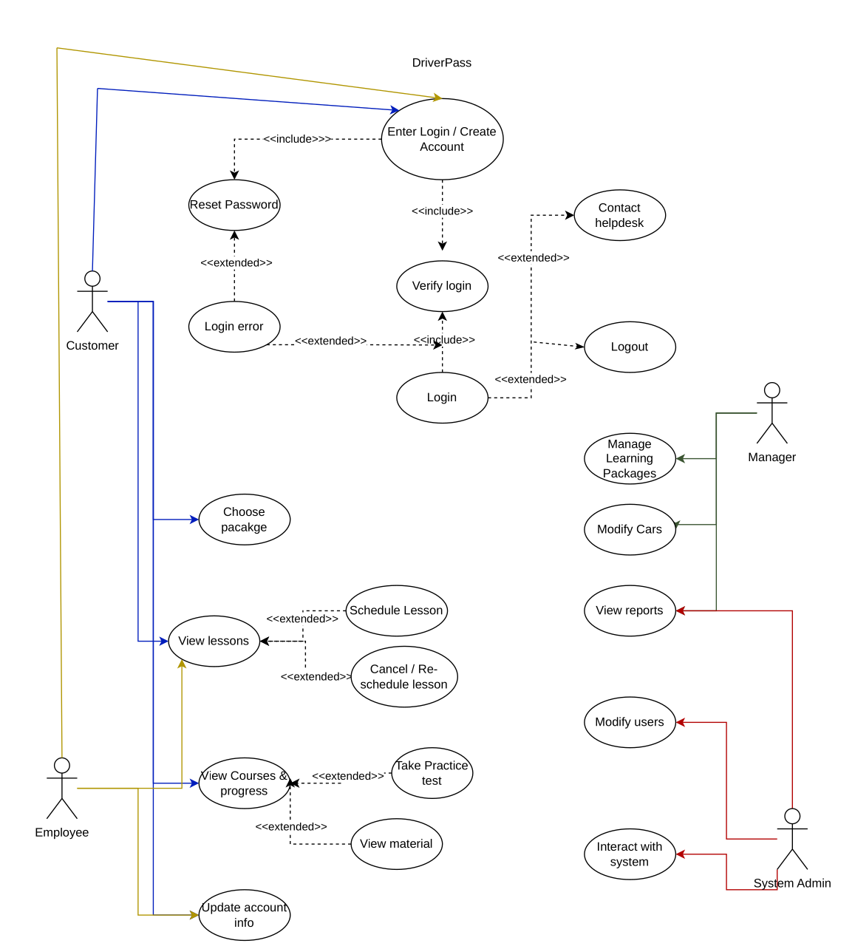

UML Activity Diagrams
User Login Activity ULM
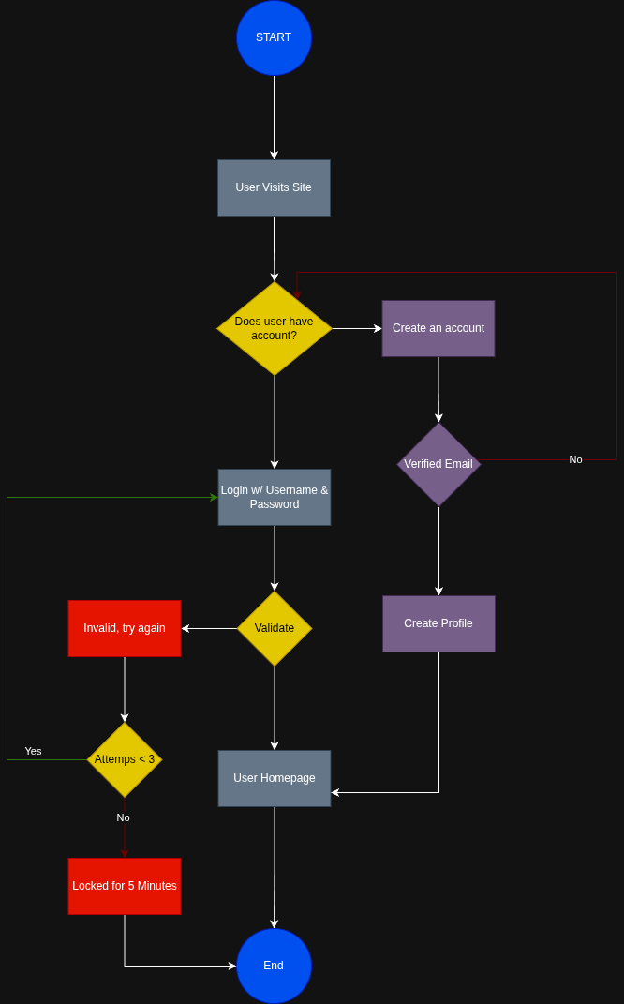

Purchase Package Activity ULM
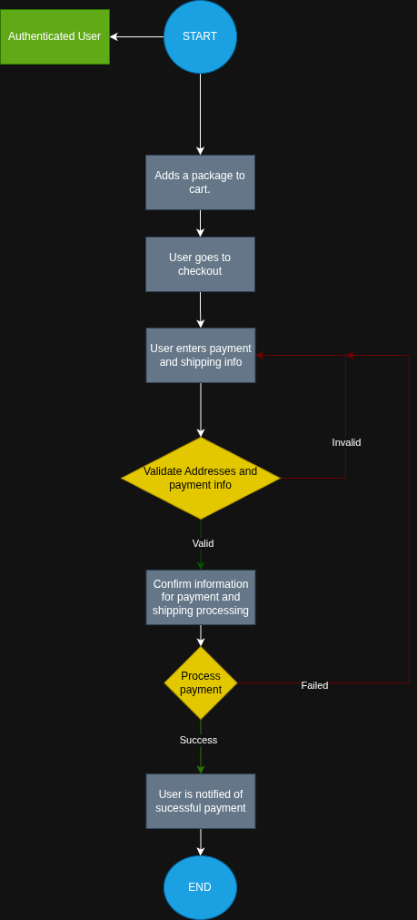

UML Sequence Diagram
Purchase Package Systems ULM
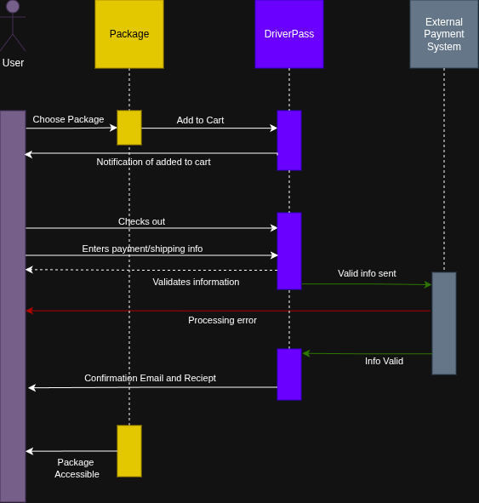

UML Class Diagram
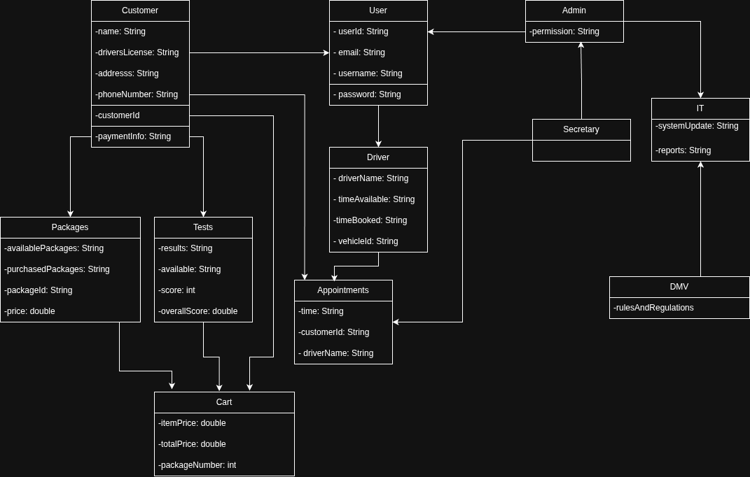

Technical Requirements
Based off of the ULM diagrams provided, the DriverPass system would need to include a server able to handle multiple users, instructors, drivers, and other staff of DriverPass at one time. This will be best achieved with a cloud based deployment, or purchase of 3 server blades, like Dell-PowerEdge. 3 Are necessary to provide high-availability for the stack of services being provided. This system will need to run the website as well as a database, likely MySQL or Postgress to handle the relationship between different entities. Multiple database servers will be used to achieve high availability for the services. The web-based application’s front end will utilize Javascript as its widely tested and used within the industry. Java will be used for backend code as it scales well and works great with databases. The code written on the project will be controlled within git, utilizing Gitlab as it works best for DevOps workflows. This will be stored utlizing Gitlab’s public servers as the scale is not necessary to self-host, however this option is available if needed.

